February 2, 2023

Ben Thomas

Rockbuster stealth LLC

data dictionary

Contents

Entity Relationship Diagram 2

Fact Table 2

1.1 Payment 2

1.2 Film_actor 2

1.3 Film_category 2

1.4 Store 3

Dimension Tables 3

2.1 Rental 3

2.2 Inventory 3

2.3 Customer 3

2.4 Staff 4

2.5 Actor 4

2.6 Film 4

2.7 Category 5

2.8 Language 5

2.9 Address 5

2.10 City 6

2.11 Country 6

# Entity Relationship Diagram

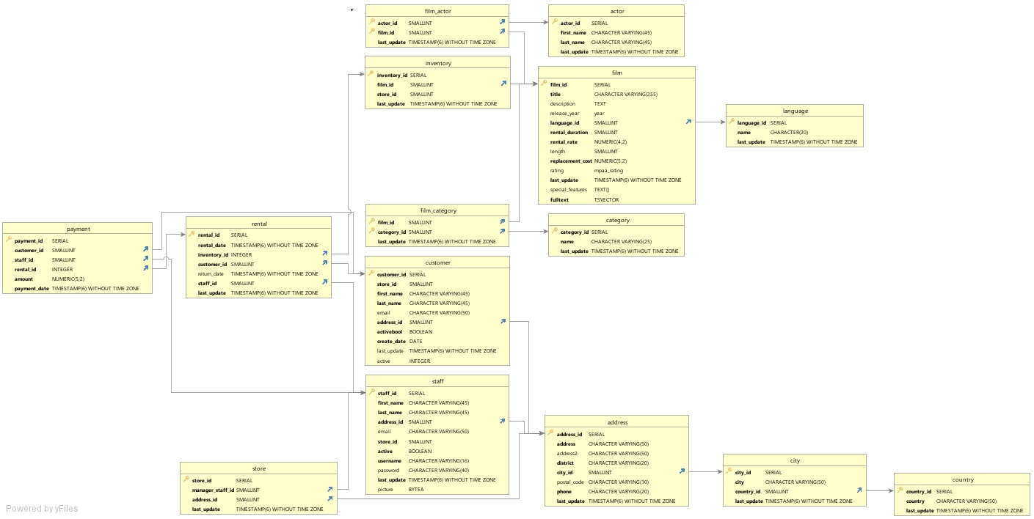

# Fact Table

## 1.1 Payment

|  |  |  |
| --- | --- | --- |
| Columns | Data Type | Description |
| payment_id | SERIAL | **Primary Key:** ID of payment |
| customer_id | SMALLINT | **Foreign Key:** ID of customer |
| staff_id | SMALLINT | **Foreign Key:** ID of staff |
| rental_id | INTEGER | **Foreign Key:** ID of rental |
| amount | NUMERIC(5,2) | Amount paid |
| payment_date | TIMESTAMP(6) WITHOUT TIME ZONE | Date of payment |

Links to:

|  |  |
| --- | --- |
| **Table** | **Column** |
| customer | customer_id |
| rental | rental_id |
| staff | staff_id |

## 1.2 Film_actor

|  |  |  |
| --- | --- | --- |
| Columns | Data Type | Description |
| actor_id | SMALLINT | **Primary Key:** ID of actor |
| film_id | SMALLINT | **Primary Key:** ID of film |
| last_update | TIMESTAMP(6) WITHOUT TIME ZONE | Time of last update |

Links to:

|  |  |
| --- | --- |
| **Table** | **Column** |
| actor | actor_id |
| film | film_id |

## 1.3 Film_category

|  |  |  |
| --- | --- | --- |
| Columns | Data Type | Description |
| film_id | SMALLINT | **Primary Key:** ID of film |
| category_id | SMALLINT | **Primary Key:** ID of the category of the film |
| last_update | TIMESTAMP(6) WITHOUT TIME ZONE | Time of last update |

Links to:

|  |  |
| --- | --- |
| **Table** | **Column** |
| film | film_id |
| category | category_id |

## 1.4 Store

|  |  |  |
| --- | --- | --- |
| Columns | Data Type | Description |
| store_id | SERIAL | **Primary Key:** ID of store |
| manager_staff_id | SMALLINT | **Foreign Key:** ID of the manager of the store |
| address_id | SMALLINT | **Foreign Key:** Address of the store |
| last_update | TIMESTAMP(6) WITHOUT TIME ZONE | Time of last update |

Links to:

|  |  |
| --- | --- |
| **Table** | **Column** |
| staff | store_id |
| address | address_id |

# Dimension Tables

## 2.1 Rental

|  |  |  |
| --- | --- | --- |
| Columns | Data Type | Description |
| rental_id | SERIAL | **Primary Key:** Serial number for rental |
| rental_date | TIMESTAMP(6) WITHOUT TIME ZONE | Date of rental |
| inventory_id | INTEGER | **Foreign Key:** ID of inventory |
| customer_id | SMALLINT | **Foreign Key:** ID of customer |
| return_date | TIMESTAMP(6) WITHOUT TIME ZONE | Date of rental return |
| staff_id | SMALLINT | **Foreign Key:** ID of the staff who rented out the inventory |
| last_update | TIMESTAMP(6) WITHOUT TIME ZONE | Time of last update |

Links to:

|  |  |
| --- | --- |
| **Table** | **Column** |
| inventory | inventory_id |
| customer | customer_id |
| staff | staff_id |

Links from:

|  |  |
| --- | --- |
| **Table** | **Column** |
| payment | rental_id |

## 2.2 Inventory

|  |  |  |
| --- | --- | --- |
| Columns | Data Type | Description |
| inventory_id | SERIAL | **Primary Key:** ID of inventory |
| film_id | SMALLINT | **Foreign Key:** ID of film |
| store_id | SMALLINT | **Foreign Key:** ID of store |
| last_update | TIMESTAMP(6) WITHOUT TIME ZONE | Time of last update |

Links to:

|  |  |
| --- | --- |
| **Table** | **Column** |
| film | film_id |

Links from:

|  |  |
| --- | --- |
| **Table** | **Column** |
| rental | inventory_id |

## 2.3 Customer

|  |  |  |
| --- | --- | --- |
| Columns | Data Type | Description |
| customer_id | SERIAL | **Primary Key:** ID of customer |
| store_id | SMALLINT | **Foreign Key:** ID of store |
| first_name | CHARACTER VARYING(45) | First name of customer |
| last_name | CHARACTER VARYING(45) | Last name of customer |
| email | CHARACTER VARYING(50) | Email of customer |
| address_id | SMALLINT | **Foreign Key:** Address of customer |
| activebool | BOOLEAN | Is the customer active |
| create_date | DATE | Date the customer activated account |
| last_update | TIMESTAMP(6) WITHOUT TIME ZONE | Time of last update |
| active | INTEGER | Is the customer active |

Links to:

|  |  |
| --- | --- |
| **Table** | **Column** |
| address | address_id |

Links from:

|  |  |
| --- | --- |
| **Table** | **Column** |
| rental | customer_id |
| payment | customer_id |

## 2.4 Staff

|  |  |  |
| --- | --- | --- |
| Columns | Data Type | Description |
| staff_id | SERIAL | **Primary Key:** ID of staff |
| first_name | CHARACTER VARYING(45) | First name of staff |
| last_name | CHARACTER VARYING(45) | Last name of staff |
| address_id | SMALLINT | **Foreign Key:** Address of staff |
| email | CHARACTER VARYING(50) | Email of staff |
| store_id | SMALLINT | **Foreign Key:** ID of store of staff |
| active | BOOLEAN | Is the employee still active |
| username | CHARACTER VARYING(16) | Username of employee |
| password | CHARACTER VARYING(40) | Password of employee |
| last_update | TIMESTAMP(6) WITHOUT TIME ZONE | Time of last update |
| picture | BYTEA | Picture of employee |

Links to:

|  |  |
| --- | --- |
| **Table** | **Column** |
| address | address_id |

Links from:

|  |  |
| --- | --- |
| **Table** | **Column** |
| payment | staff_id |
| rental | staff_id |
| store | store_id |

## 2.5 Actor

|  |  |  |
| --- | --- | --- |
| Columns | Data Type | Description |
| actor_id | SERIAL | **Primary Key:** ID of actor |
| first_name | CHARACTER VARYING(45) | First name of actor |
| last_name | CHARACTER VARYING(45) | Last name of actor |
| last_update | TIMESTAMP(6) WITHOUT TIME ZONE | Time of last update |

Links from:

|  |  |
| --- | --- |
| **Table** | **Column** |
| film_actor | actor_id |

## 2.6 Film

|  |  |  |
| --- | --- | --- |
| Columns | Data Type | Description |
| film_id | SERIAL | **Primary Key:** ID of film |
| title | CHARACTER VARYING(255) | Title of film |
| description | TEXT | Description of film |
| release_year | year | Year film was released |
| language_id | SMALLINT | **Foreign Key:** Language of film |
| rental_duration | SMALLINT | Duration of rental |
| rental_rate | NUMERIC(4,2) | Cost of rental |
| length | SMALLINT | Length of film |
| replacement_cost | NUMERIC(5,2) | Cost to replace rental |
| rating | mpaa_rating | Rating of film |
| last_update | TIMESTAMP(6) WITHOUT TIME ZONE | Time of last update |
| special_features | TEXT | Indicates special features such as trailers/deleted scenes/commentaries |
| fulltext | TSVECTOR | Key words and count of those words |

Links to:

|  |  |
| --- | --- |
| **Table** | **Column** |
| language | language_id |

Links from:

|  |  |
| --- | --- |
| **Table** | **Column** |
| film_actor | film_id |
| film_category | film_id |
| inventory | film_id |

## 2.7 Category

|  |  |  |
| --- | --- | --- |
| Columns | Data Type | Description |
| category_id | SERIAL | **Primary Key:** Generic number for category |
| name | CHARACTER VARYING(25) | Genre type |
| last_update | TIMESTAMP(6) WITHOUT TIME ZONE | Time of last update |

Links from:

|  |  |
| --- | --- |
| **Table** | **Column** |
| film_category | category_id |

## 2.8 Language

|  |  |  |
| --- | --- | --- |
| Columns | Data Type | Description |
| language_id | SERIAL | **Primary Key:** Generic number for language |
| name | CHARACTER(20) | Language |
| last_update | TIMESTAMP(6) WITHOUT TIME ZONE | Time of last update |

Links from:

|  |  |
| --- | --- |
| **Table** | **Column** |
| film | language_id |

## 2.9 Address

|  |  |  |
| --- | --- | --- |
| Columns | Data Type | Description |
| address_id | SERIAL | **Primary Key:** Generic number for address |
| address | CHARACTER VARYING(50) | First line of address |
| address2 | CHARACTER VARYING(50) | Second line of address |
| district | CHARACTER VARYING(20) | District of address |
| city_id | SMALLINT | **Foreign Key:** ID of address |
| postal_code | CHARACTER VARYING(10) | Postal code of address |
| phone | CHARACTER VARYING(20) | Phone number for address |
| last_update | TIMESTAMP(6) WITHOUT TIME ZONE | Time of last update |

Links to:

|  |  |
| --- | --- |
| **Table** | **Column** |
| city | city_id |

Links from:

|  |  |
| --- | --- |
| **Table** | **Column** |
| staff | address_id |
| customer | address_id |
| store | address_id |

## 2.10 City

|  |  |  |
| --- | --- | --- |
| Columns | Data Type | Description |
| city_id | SERIAL | **Primary Key:** ID of city |
| city | CHARACTER VARYING(50) | City |
| country_id | SMALLINT | **Foreign Key:** ID of country |
| last_update | TIMESTAMP(6) WITHOUT TIME ZONE | Time of last update |

Links to:

|  |  |
| --- | --- |
| **Table** | **Column** |
| country | country_id |

Links from:

|  |  |
| --- | --- |
| **Table** | **Column** |
| address | city_id |

## 2.11 Country

|  |  |  |
| --- | --- | --- |
| Columns | Data Type | Description |
| country_id | SERIAL | **Primary Key:** ID of country |
| country | CHARACTER VARYING(50) | Country |
| last_update | TIMESTAMP(6) WITHOUT TIME ZONE | Time of last update |

Links from:

|  |  |
| --- | --- |
| **Table** | **Column** |
| city | country_id |